Taylor Gebreyohannes
November 2025
Baruch College, Finance BBA

AI & Advisory: How UBS Is Redefining Wealth & Asset Management Through Artificial Intelligence
Prepared by Taylor Gebreyohannes ahead of a discussion with a UBS Executive Director on the future of AI in Wealth Management.
In preparation for a meeting with a senior executive at UBS Wealth Management, I conducted an in-depth analysis of the firm’s evolving strategic priorities. My research revealed that UBS is actively integrating Artificial Intelligence (AI) into its advisory framework to enhance advisor efficiency, streamline operations, and deepen client engagement.
During the UBS Greater New York Growth Summit, moderated by Christopher Perry Simone, a key session titled “Investing Across the AI Value Chain” explored how AI is creating value across sectors—from managing large-scale energy and power demands to identifying opportunities in private markets that will drive the next wave of innovation. Similarly, in a recent discussion between Mara Glassel and Robert Karofsky, UBS emphasized its commitment to leveraging technology to help advisors grow, while reinforcing its focus on personalized client support and long-term relationship building.
Why AI Matters Now for Advisory and Asset Management.
As the race to harness artificial intelligence accelerates, the wealth management industry is entering a pivotal new phase. According to McKinsey’s 2024 report, “U.S. Wealth Management: Amid Market Turbulence, an Industry Converges,” technology has become the backbone of modern advisory models. Over the past five years, technology spending in the sector has consistently outpaced both revenue and cost growth—rising 9% annually, compared with 8% for revenue and 7% for costs, including a sharp 19% surge in 2022 alone.
This rapid acceleration underscores how critical digital infrastructure and automation have become to both client engagement and organizational efficiency. In essence, technology is no longer a supporting function, it is the foundation of sustainable client relationships and operational excellence.
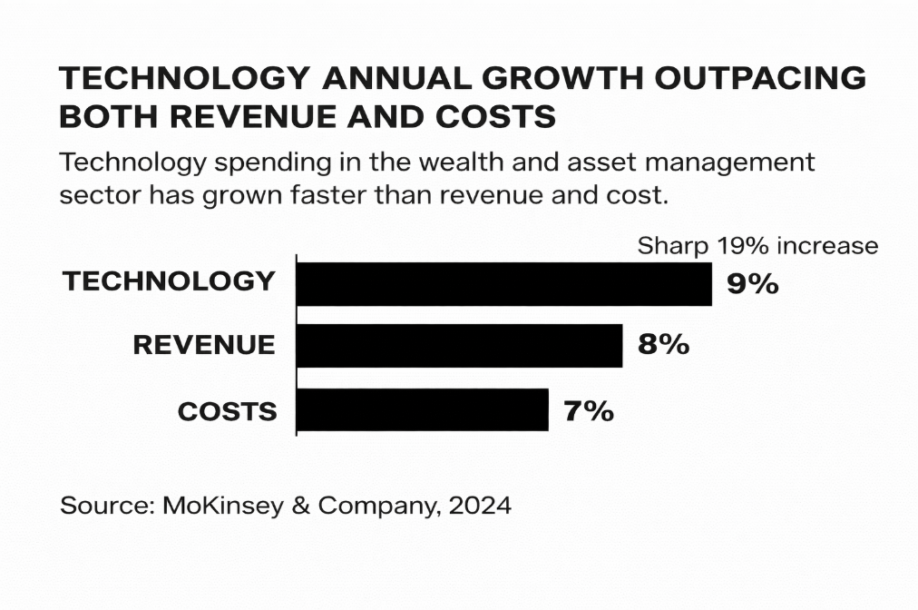
McKinsey emphasizes that the emergence of generative AI represents a “once-in-a-generation opportunity” for wealth managers to reinvent how advisors work. Rather than replacing advisors, AI enhances them—automating lower-value administrative tasks while freeing time for higher-value client interactions. Generative AI tools are already being used to summarize meeting notes, draft financial plans, support compliance documentation, and serve as virtual assistants that extend human productivity. As a result, McKinsey estimates that the average wealth advisor could reallocate 20–30% of their time toward growth-related and client-facing activities.
This shift in focus—from routine operations to strategic growth—has profound implications for firms like UBS. As AI systems mature, they will enable advisors to analyze larger data sets, uncover patterns in client behavior, and deliver tailored advice faster than ever before. The firms that combine technological investment with disciplined risk management and cultural adaptability will emerge as long-term winners. McKinsey concludes that “outperformance will come from those that make the right big bets”—a principle that aligns with UBS’s current strategy of leveraging AI to strengthen advisor-client relationships and drive personalized financial outcomes.
This acceleration in technology investment signals a permanent transformation across the wealth management landscape. Firms that successfully integrate AI into advisory workflows are gaining an operational and competitive edge—delivering faster insights, more personalized strategies, and stronger client relationships. UBS, with its focus on advisor empowerment and digital innovation, is strategically positioned to lead this shift. By continuing to invest in AI-driven platforms and analytics, UBS can enhance advisor productivity, strengthen client engagement, and capture long-term growth opportunities in a rapidly evolving market.

UBS Financial Strength & Capacity for AI Investment

This section examines how UBS’s current financial position supports its capacity to invest in and scale artificial intelligence across its wealth-management operations. Recent financial results highlight the firm’s resilience and ability to pursue innovation from a position of strength.

According to Bloomberg data, UBS recorded revenue growth of over 21% in 2023 and nearly 19% in 2024, while its operating income margin more than doubled during the same period. Coupled with a Tier 1 capital ratio of roughly 18.8%, these results underscore UBS’s solid capitalization and its ability to fund long-term digital and AI transformation initiatives without compromising stability.

This performance reflects more than financial discipline; it signals a phase of expansion and modernization. UBS’s profitability trajectory provides the foundation to scale next-generation AI capabilities, especially within wealth management, where advisor productivity and client experience remain key strategic levers. As McKinsey notes, firms that successfully integrate generative AI into advisory workflows can reallocate 20–30% of advisor time toward growth-oriented and client-facing activities. UBS is structurally and financially positioned to be among those outperformers.

As illustrated in the UBS Financial Growth and Efficiency (2023–2026E) chart, the firm’s net revenue has remained robust, averaging approximately $50 billion annually, while both operating income and operating margins have strengthened significantly. Operating income—representing profit generated from UBS’s core business before taxes—is projected to increase from roughly $2.7 billion in 2023 to nearly $11.9 billion by 2026, reflecting major improvements in operational performance and profitability. No advisors
Meanwhile, UBS’s operating margin, the share of profit retained from each dollar of revenue—has expanded from 6.3% to nearly 19%, effectively tripling efficiency within three years. While much of the industry is still racing to modernize, UBS is investing in technology from a position of exceptional financial strength.
To put this in perspective, UBS’s revenue grew by over 21% in 2023 and nearly 19% in 2024, while its operating income margin more than doubled. For every $100 UBS earns, the firm now retains about $19 in operating profit, compared with just $6 three years earlier—a clear demonstration of cost discipline, scalability, and execution strength even amid challenging market conditions.
These gains underscore UBS’s ability to continue investing in transformative technologies such as artificial intelligence (AI). The firm’s rising profitability and operational efficiency indicate that its digital initiative automating advisor workflows, enhancing client personalization, and strengthening compliance processes—are already delivering measurable impact. UBS’s strong capital position enables it to further leverage AI to sustain growth, elevate advisor productivity, and deliver superior client experience in the years ahead.
Ultimately, UBS’s improving efficiency and profitability signal more than prudent management—they represent a strategic shift toward intelligent growth. As AI becomes the foundation of competitive advantage in global finance, UBS’s disciplined execution and forward-looking investments suggest that it is not merely adapting to technological change but actively shaping it. By continuing to embed AI across its wealth management operations—optimizing advisor workflows, deepening personalization, and automating analytics, UBS can set a new benchmark for how human expertise and technology converge in modern finance. This transformation is not about replacing advisors, but amplifying their value, ensuring UBS remains a leader in a data-driven, client-first era of wealth management.
Global AI Adoption & UBS’s Competitive Edge
Across Asia, the private wealth management industry is experiencing rapid expansion, driven by the adoption of AI-enabled client engagement tools and advanced digital infrastructure. According to a Bloomberg Intelligence survey, more than 75% of private-wealth professionals expect net new money inflows to increase by at least 6% annually, with Hong Kong and Singapore emerging as leading AI-powered wealth hubs.
These markets illustrate how automation and predictive analytics can significantly enhance productivity while preserving the human element of advisory work—fewer than 3% of respondents anticipate workforce reductions. Drawing from these insights, UBS can apply similar strategies in Western markets by leveraging AI to refine client segmentation, automate portfolio monitoring, and strengthen its cross-border wealth management capabilities.
UBS’s improving return on equity (ROE) and cost synergies—estimated at $13 billion by 2026—show that its integration strategy is paying off. Bloomberg data indicates UBS’s ROE (around 8.5%) is trending upward, surpassing Deutsche Bank and approaching BNP Paribas, reflecting superior cost management and technology leverage. These gains suggest UBS’s structure is increasingly aligned with AI-driven efficiency models seen in Asia, where digital wealth platforms have already demonstrated faster growth and stronger margins. The key for UBS will be scaling similar automation and client analytics capabilities across its global advisory base to capture comparable returns.
While AI adoption has accelerated wealth growth in Asia, UBS’s unique position as a global institution allows it to merge these innovations with its established European and U.S. presence. By combining lessons from Asia’s AI-led private wealth surge with its own financial stability and cross-border expertise, UBS can position itself as a global benchmark for hybrid human-AI advisory—balancing data precision with personalized service.
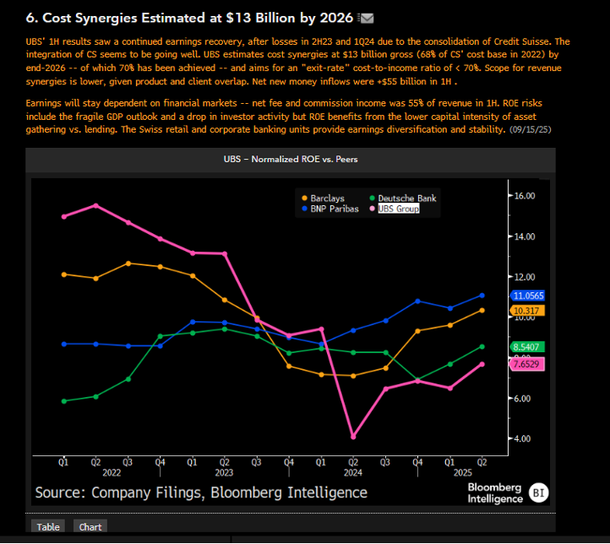

The Future of AI and UBS’s Long-Term Outlook.

The future of wealth management will be shaped by firms that can most effectively integrate artificial intelligence into human decision-making. As AI continues to advance, it will assume increasingly complex analytical responsibilities—such as portfolio modeling, risk monitoring, and client personalization—allowing advisors to focus on higher-value activities like relationship management and strategic guidance. Rather than replacing human judgment, AI will enhance it—equipping advisors with greater data precision, deeper client insights, and faster decision-making capabilities.

For UBS, the long-term outlook is highly promising. With strong capital ratios, rising profitability, and sustained investment in digital transformation, the firm is well positioned to lead the transition into an AI-empowered era of wealth management. Over the next five years, UBS can continue leveraging AI to streamline client onboarding, automate operational workflows, and deliver real-time, hyper-personalized advice—advancing both efficiency and client satisfaction.

Ultimately, the success of AI adoption in wealth management will depend not only on technological capability but also on culture—how effectively firms empower advisors to use AI responsibly, creatively, and confidently. UBS’s combination of financial strength, global reach, and commitment to innovation gives it a distinctive advantage to define this future and set a new global benchmark for modern, technology-enabled wealth management.

Sources Cited

The Bloomberg Terminal, UBS Group AG Financial Highlights (2023–2026E), accessed November 2025.
McKinsey & Company, U.S. Wealth Management: Amid Market Turbulence, an Industry Converges (2024).
Bloomberg Intelligence, Asia Private Wealth Survey (2024).

